So this is the initialization

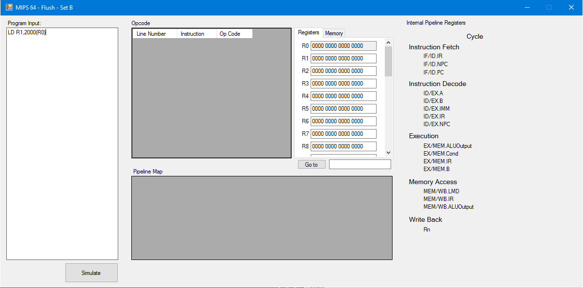

Each memory is in an Array from 0 – 8192 Where 0 is 2000, 1 is 2001, 2 is 2002…, 8192 is 3FFF

Here’s the problem regarding the memory

3FFF becomes memory[0]

3FFE becomes memory[1]

3FFD becomes memory[2]

Etc.

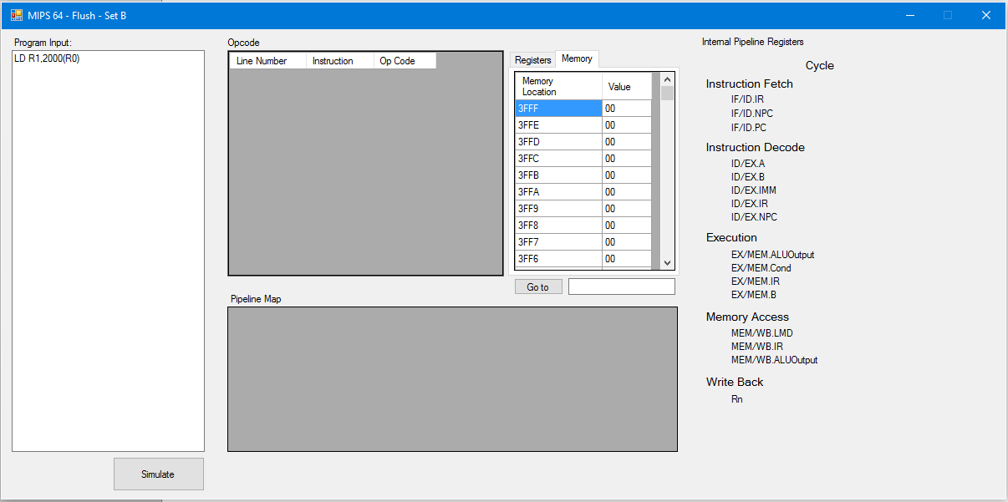

When you re-sort it, the memory array doesn’t move!!

2000 is still memory[0]

2001 is still memory[1]

2002 is still memory[2]

Etc.

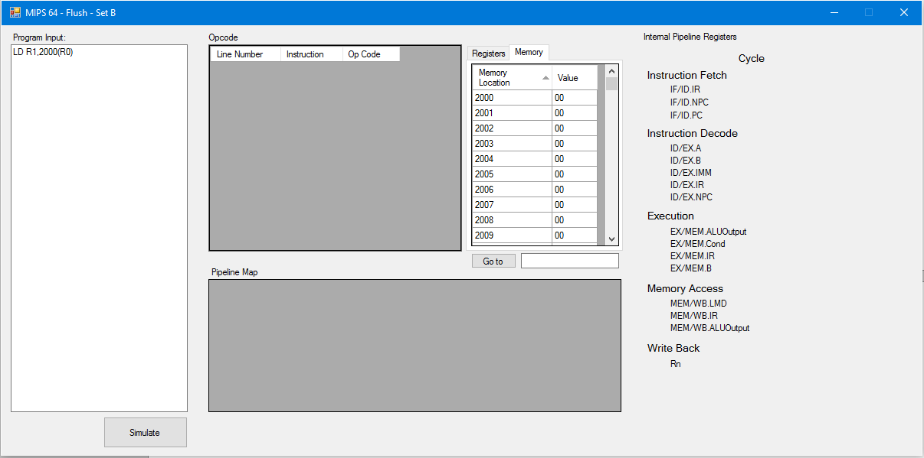

Try it yourself!

Program:

LD R1,2000(R0)

|  |  |
| --- | --- |
| 3FFF | 55 |
| 3FFE | 44 |
| 3FFD | 33 |
| 3FFC | 22 |
| 3FFB | 11 |
| 3FFA | EF |
| 3FF9 | CD |
| 3FF8 | AB |

The answer should becomes 5544 3322 11EF CDAB because the first row is memory[0]

BUTT if you re-sort it,

|  |  |
| --- | --- |
| 2000 | 55 |
| 2001 | 44 |
| 2002 | 33 |
| 2003 | 22 |
| 2004 | 11 |
| 2005 | EF |
| 2006 | CD |
| 2007 | AB |

The answer is ABCD EF11 2233 4455 which is supposed to be correct.

So to fix the problem either keep is in ascending order like the 2nd table and not allow to sort the columns.

Or stick to the format of the 3rd table BUT make instruction[8192] be the 3FFF and not allow to sort the columsn